FLOOD MONITORING & EARLY WARNING

**The Team:**

* **DEEPIKA.T**
* **ASHWINIPRIYA.S**
* **CHITRA.J**
* **JEYANTHI.V**
* **VIJAYALAKSHMI.J**

**ABSTRACT**

Flood are the most damaging natural disaster in the world on the occasion of heavy flood, it can destroy the community and killed many lives. The government would spend billions of dollars to recover the affected area.It is crucial to develop a flood control system as a mechanism to reduce the flood risk .Providing a quick feedback on the occurrence of the flood is necessary for alerting resident to take early action such as evacuate quickly to a safer and higher place.as solution to this paper propose a system that is not only able to dtect the water level but also alert about bridge collapse. The development of an android application for all the vehicle owners that uses their smart phones while travelling and getting flood report on the route that they are going to pass through. Working with raspberry pi to detecting the flood, the application alerts the user if their vehicle can either pass though the flood safely, proceed with precaution or shouldn’t pass the route at all because of the flood.

Keywords: Raspberry pi, IOT based system

**I. INTRODUCTION**

Natural disaster happens everywhere in the world, they can be completely disturbing the human life and the economy of the country. Economy and growth of any country depend upon agriculture alert forecasting makes the farmer to protect the crop from flooding. The system is much advantaged for protecting lives of people and animal. The proposed model is very much utilized for monitoring of the water level, flow variance in rivers and the same can be used for measuring water level at dam or on river bridges. The measured value is regularly updated on web server which is very much useful to send flood alerts to consist authority and people for faster action. The project mainly constitutes a wireless sensor to monitor water condition.

**METHODS AND MATERIAL**

**Proposed System**

The prototype of proposed system can be Implemented using Raspberry pi. The proposed System block diagram is shown in the Fig. 1.The Raspberry Pi receives Information from Connected input devices, processes the data and Triggers the data based on pre-programmed Parameters. Raspberry pi will send the values measured by sensors to the ser.

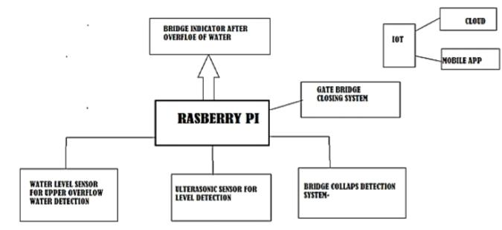

**Fig.1System Block Diagram**

**Block Diagram Explanation**

**Level sensor:** level sensors are used for the Measurement of the water level. Such substances can Be liquids like water, oil, slurries as well as solids Which can flow.

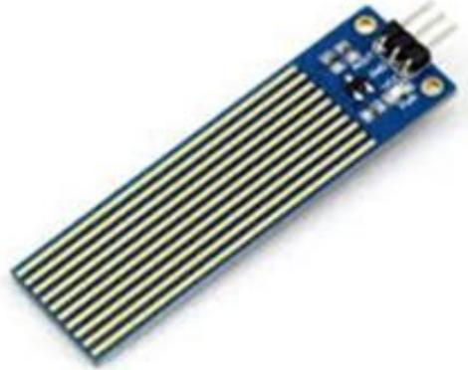

**Fig.2**

ultrasonic receiver would detect the reflected wave and stop the stop timer.

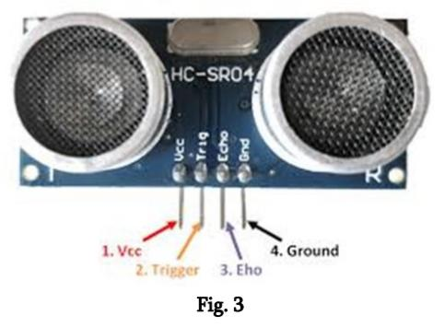

**Raspberry pi:** Raspberry pi is a series of single board computers developed by the raspberry pi foundation for basic computer science in schools for developing countries. Raspberry pi models have one thing in common, through: they are compatible, meaning that software written for one model will run on any other model. It’s even possible to take the very latest version of the raspberry pi operating system and run it on an original pre-launch model B prototype. It will run more slowly, but it will still run.

**System Flow Diagram**

The software flow for the given system is given in Three approaches as data collection, data Transmission And display of data.

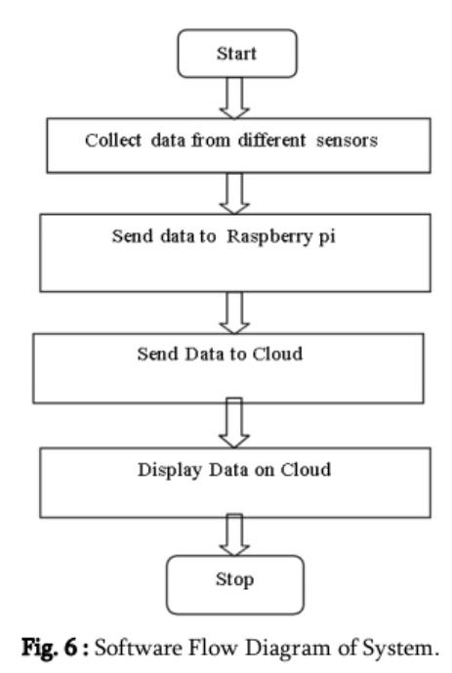

**Fig.4 Software Flow Diagram of System**

**RESULTS AND DISCUSSION**

We have Successfully design system for flood alerting And monitoring.

**CONCLUSION**

As India faced recent devastating floods in Maharashtra, there arise a need of efficient flood Monitoring and alerting system. The system discussed In this paper is beneficial to people for decision Making and evacuation planning in floods.